|  |  |  |  |  |  |  |  |
| --- | --- | --- | --- | --- | --- | --- | --- |
| **Nursery & Reception** | **Ourselves & Families** | | | | | | |
| [Fruits](https://www.amazon.co.uk/Fruits-Valerie-Bloom/dp/1529007569/ref=sr_1_1?crid=3LMRKVS23PPCO&dchild=1&keywords=fruits+a+caribbean+counting+poem&qid=1593416719&s=books&sprefix=fruits+a+,stripbooks,156&sr=1-1)[Can I Join Your Club?](https://www.amazon.co.uk/Can-I-Join-Your-Club/dp/1848694369/ref=sr_1_1?dchild=1&keywords=Can+I+join+your+club&qid=1593416545&s=books&sr=1-1)[King and King](https://www.amazon.co.uk/King-Linda-Haan/dp/1582460612/ref=sr_1_1?dchild=1&keywords=The+king+and+the+king&qid=1593416495&s=books&sr=1-1)[Billy and the Dragon](https://www.amazon.co.uk/Billy-Dragon-Nadia-Shireen/dp/0857551353/ref=sr_1_1?dchild=1&keywords=Billy+and+the+dragon&qid=1593416462&s=books&sr=1-1)[Ruby's Worry: A Big Bright Feelings Book: Amazon.co.uk: Percival ...](https://www.google.co.uk/url?sa=i&url=https://www.amazon.co.uk/Rubys-Worry-Tom-Percival/dp/1408892154&psig=AOvVaw2fTjwq3eGaNXEuvEq4zQ7A&ust=1593502372275000&source=images&cd=vfe&ved=0CAIQjRxqFwoTCKi1pf7ApuoCFQAAAAAdAAAAABAE)[Handa's Surprise](https://www.amazon.co.uk/Handas-Surprise-Eileen-Browne/dp/0744536340/ref=sr_1_1?crid=1GQL0HZ74P5UK&dchild=1&keywords=handas+surprise&qid=1593416427&s=books&sprefix=Handas+,stripbooks,165&sr=1-1)[My Hair](https://www.amazon.co.uk/My-Hair-Hannah-Lee/dp/0571346871/ref=sr_1_1?dchild=1&keywords=my+hair&qid=1593416389&s=books&sr=1-1)[Introducing Teddy](https://www.amazon.co.uk/Introducing-Teddy-Jessica-Walton/dp/1408877627/ref=sr_1_1?dchild=1&keywords=introducing+teddy&qid=1593416228&s=books&sr=1-1)[Bunnybear](https://www.amazon.co.uk/Bunnybear-Andrea-J-Loney/dp/0807509388/ref=sr_1_1?dchild=1&keywords=bunnybear&qid=1593416179&s=books&sr=1-1)https://images-na.ssl-images-amazon.com/images/I/51vR5TkbAYL._SX384_BO1,204,203,200_.jpg  [Kite Flying](https://www.amazon.co.uk/Kite-Flying-Grace-Lin/dp/0553112546/ref=sr_1_1?dchild=1&keywords=kite+flying&qid=1593416829&s=books&sr=1-1)  https://images-na.ssl-images-amazon.com/images/I/51kigswqPlL._SX377_BO1,204,203,200_.jpghttps://images-na.ssl-images-amazon.com/images/I/51UAfBXW3BL._SX387_BO1,204,203,200_.jpgBlanket of Love (New Books for Newborns) by [Alyssa Satin Capucilli, Brooke Boynton-Hughes][Families Families Families](https://www.amazon.co.uk/Families-Suzanne-Lang/dp/0552572926/ref=sr_1_1?crid=16B7XQT39OEM1&dchild=1&keywords=families+families+families&qid=1593418456&s=books&sprefix=families+fa,stripbooks,165&sr=1-1)[Marisol McDonald Doesn't Match: Marisol McDonald No Combina](https://www.amazon.co.uk/Marisol-McDonald-Doesnt-Match-Combina/dp/0892392355/ref=sr_1_1?crid=V6T8XNL35H8U&dchild=1&keywords=marisol+mcdonald+doesn't+match&qid=1593416791&s=books&sprefix=marisolmcdonald+,stripbooks,178&sr=1-1)[So Much](https://www.amazon.co.uk/So-Much-Trish-Cooke/dp/1406390720/ref=sr_1_1?dchild=1&keywords=so+much&qid=1593416750&s=books&sr=1-1)https://images-na.ssl-images-amazon.com/images/I/51VgY1eCnPL._SY483_BO1,204,203,200_.jpg[My Pet Star](https://www.amazon.co.uk/My-Pet-Star-Corrinne-Averiss/dp/1408353660/ref=sr_1_1?dchild=1&keywords=my+pet+star&qid=1593416636&s=books&sr=1-1) | | | | | | | |
| **Year 1** | **Literacy Text** | **Links To History** | **Links To Science** | **Links To Geography** | **Diversity Texts** | **Stand Alone Texts/SMSC/Class Story** | **Famous People/Activists** |
|  | [Little Red and the Very Hungry Lion](https://www.amazon.co.uk/Little-Red-Very-Hungry-Lion/dp/1407143905/ref=sr_1_1?dchild=1&keywords=little+red+and+the+very+hungry+lion&qid=1593417706&s=books&sr=1-1)Twist on traditional tale | Families  https://images-na.ssl-images-amazon.com/images/I/51oloarld6L._SY403_BO1,204,203,200_.jpg  [Hair Love: Based on the Oscar-Winning Short Film](https://www.amazon.co.uk/Hair-Love-Matthew-Cherry/dp/0241406420/ref=sr_1_1?dchild=1&keywords=hair+love&qid=1593417385&s=books&sr=1-1)  [The New Small Person](https://www.amazon.co.uk/New-Small-Person-Lauren-Child/dp/0723293619/ref=sr_1_1?crid=2VERAHECH5O19&dchild=1&keywords=the+new+small+person&qid=1593417846&s=books&sprefix=the+new+sma,stripbooks,178&sr=1-1) | Nocturnal animals  [Handa's Noisy Night](https://www.amazon.co.uk/Handas-Noisy-Night-Eileen-Browne/dp/1406320013/ref=sr_1_1?crid=52HFS3I7EELH&dchild=1&keywords=handas+noisy+night&qid=1593417122&s=books&sprefix=Handas,stripbooks,211&sr=1-1)  Birds - Reptiles  https://images-na.ssl-images-amazon.com/images/I/51SjiA-xS8L._SY407_BO1,204,203,200_.jpg | https://images-na.ssl-images-amazon.com/images/I/51b51XdXk-L._SX412_BO1,204,203,200_.jpgLocal environments | [The Different Dragon](https://www.amazon.co.uk/Different-Dragon-Jennifer-Bryan/dp/0967446864/ref=sr_1_2?dchild=1&keywords=the+different+dragon&qid=1593417343&s=books&sr=1-2)  [Jack (Not Jackie)](https://www.amazon.co.uk/Jack-Not-Jackie-Erica-Silverman/dp/1499807317/ref=sr_1_1?crid=22A7H9RDTP378&dchild=1&keywords=jack+not+jackie&qid=1593419318&s=books&sprefix=jack+not+,stripbooks,175&sr=1-1) | https://images-na.ssl-images-amazon.com/images/I/5122KtrgY7L._SX497_BO1,204,203,200_.jpg | [www.gstatic.com/tv/thumb/persons/291403/291403_...](http://google.com/search?tbm=isch&q=Meghan+Markle)Meghan Markle (Link to history section – Queen) |

**DIVERISTY AND EQUALITY TEXT MAPPING 2020 2021**

|  |  |  |  |  |  |  |  |
| --- | --- | --- | --- | --- | --- | --- | --- |
| **Year 2** | **Literacy Text** | **Links To History** | **Science** | **Links To Geography** | **Diversity Text** | **Stand Alone Texts/SMSC/Class Story** | **Famous People/Activists** |
|  |  | https://images-na.ssl-images-amazon.com/images/I/610nZiMUWlL._SX408_BO1,204,203,200_.jpg**Space**  https://images-na.ssl-images-amazon.com/images/I/51DQpot-IeL._SX258_BO1,204,203,200_.jpg | **[Sonya's Chickens](https://www.amazon.co.uk/Sonyas-Chickens-Phoebe-Wahl/dp/1770497900/ref=sr_1_1?dchild=1&keywords=sonyas+chickens&qid=1593419607&s=books&sr=1-1)Life cycles**  [Izzy Gizmo](https://www.amazon.co.uk/Izzy-Gizmo-Pip-Jones/dp/0857075136/ref=sr_1_1?dchild=1&keywords=izzy+gizmo&qid=1593416674&s=books&sr=1-1)**Scientific Enquiry** |  | [And Tango Makes Three (Classic Board Books)](https://www.amazon.co.uk/Tango-Makes-Three-Classic-Board/dp/1481446959/ref=sr_1_1?dchild=1&keywords=tango+makes+3&qid=1593419657&s=books&sr=1-1)  [Mixed](https://www.amazon.co.uk/Mixed-Arree-Chung/dp/1509871349/ref=sr_1_1?dchild=1&keywords=mixed&qid=1593420086&s=books&sr=1-1) |  | **Space – Dr Mae Jemison**  [Mae Jemison - Wikipedia](https://www.google.co.uk/url?sa=i&url=https://en.wikipedia.org/wiki/Mae_Jemison&psig=AOvVaw1FcKDtAE5VDQXGmjvi0Onb&ust=1593506420709000&source=images&cd=vfe&ved=0CAIQjRxqFwoTCMjbzojQpuoCFQAAAAAdAAAAABAE) |
| **Year 3** | **Literacy Text** | **Links To History** | **Science** | **Links to Geography** | **Diversity Text** | **Stand Alone Texts/SMSC/Class Story** | **Famous People/Activists** |
|  |  |  | **Scientific Enquiry**  [Ada Twist, Scientist: 1](https://www.amazon.co.uk/Ada-Twist-Scientist-Andrea-Beaty/dp/1419721372/ref=sr_1_1?crid=1FQIC88XBCEO0&dchild=1&keywords=ada+twist+scientist&qid=1593420268&s=books&sprefix=Ada+,stripbooks,178&sr=1-1)  [Izzy Gizmo and the Invention Convention](https://www.amazon.co.uk/Untitled-Pip-Jones-Pa/dp/1471145247/ref=sr_1_1?crid=269OA9BAR1512&dchild=1&keywords=izzy+gizmo+and+the+invention+convention&qid=1593417918&s=books&sprefix=izzy+gizmo+,stripbooks,178&sr=1-1) |  | https://images-na.ssl-images-amazon.com/images/I/51L-kMb+kML._SX393_BO1,204,203,200_.jpg[Perfectly Norman: A Big Bright Feelings Book](https://www.amazon.co.uk/Perfectly-Norman-Tom-Percival/dp/1408880970/ref=sr_1_1?dchild=1&keywords=perfectly+norman&qid=1593420416&s=books&sr=1-1) | [Unexpected Super Spy: Book 2 (Planet Omar)](https://www.amazon.co.uk/Unexpected-Super-Spy-Book-Planet/dp/1444951270/ref=sr_1_3?dchild=1&keywords=planet+Omar&qid=1593423177&s=books&sr=1-3)[Incredible Rescue Mission (Planet Omar)](https://www.amazon.co.uk/Incredible-Rescue-Mission-Planet-Omar/dp/1444951297/ref=sr_1_2?dchild=1&keywords=planet+Omar&qid=1593423177&s=books&sr=1-2)[Accidental Trouble Magnet: Book 1 (Planet Omar)](https://www.amazon.co.uk/Accidental-Trouble-Magnet-Book-Planet/dp/144495122X/ref=sr_1_1?dchild=1&keywords=planet+Omar&qid=1593423177&s=books&sr=1-1) | https://images-na.ssl-images-amazon.com/images/I/61BMc6CqKBL._SX408_BO1,204,203,200_.jpg |

|  |  |  |  |  |  |  |  |
| --- | --- | --- | --- | --- | --- | --- | --- |
| **Year 4** | **Literacy Text** | **Links To History** | **Science** | **Links To Geography** | **Diversity Text** | **Stand Alone Texts/SMSC/Class Story** | **Famous People /Activists** |
|  |  | [Septimius Severus - Ancient History Encyclopedia](https://www.google.co.uk/url?sa=i&url=https://www.ancient.eu/Septimius_Severus/&psig=AOvVaw38ACFMsIra3X7DQ-1GfZir&ust=1593508239801000&source=images&cd=vfe&ved=0CAIQjRxqFwoTCNje_-vWpuoCFQAAAAAdAAAAABAE)**Septimus Serverus** | **Scientific Enquiry**  [Ada Twist and the Perilous Pantaloons (The Questioneers): 1](https://www.amazon.co.uk/Ada-Twist-Perilous-Pantaloons-Questioneers/dp/1419739018/ref=sr_1_1?dchild=1&keywords=ada+twist+scientist+and+the+perilous+pantaloons&qid=1593422365&s=books&sr=1-1)  [Lewis Howard Latimer - Inventions, Facts & Accomplishments - Biography](https://www.google.co.uk/url?sa=i&url=https://www.biography.com/inventor/lewis-howard-latimer&psig=AOvVaw1eiwPipegjStaPBYxZaGgD&ust=1593510960192000&source=images&cd=vfe&ved=0CAIQjRxqFwoTCKDPlv3gpuoCFQAAAAAdAAAAABAE)**Inventor of the electric lightbulb – Lewis Howard Latimer** |  | https://images-na.ssl-images-amazon.com/images/I/511ENv3LBML._SY459_BO1,204,203,200_.jpg[RED: A Crayon's Story](https://www.amazon.co.uk/Red-Crayons-Story-Michael-Hall/dp/0062252070/ref=sr_1_1?dchild=1&keywords=red+crayon&qid=1593422216&s=books&sr=1-1) | [The Proudest Blue: A Story of Hijab and Family](https://www.amazon.co.uk/Proudest-Blue-Story-Hijab-Family/dp/0316519006/ref=sr_1_1?dchild=1&keywords=the+proudest+blue&qid=1593423686&s=books&sr=1-1) | **Link to History (Romans)**  **Septimus Serverus –African born Roman strengthened Hadrains wall**  [Septimius Severus - Ancient History Encyclopedia](https://www.google.co.uk/url?sa=i&url=https://www.ancient.eu/Septimius_Severus/&psig=AOvVaw38ACFMsIra3X7DQ-1GfZir&ust=1593508239801000&source=images&cd=vfe&ved=0CAIQjRxqFwoTCNje_-vWpuoCFQAAAAAdAAAAABAE)  **Lorna Simpson – Photographer link to art**  [Lorna Simpson | Biography, Art, & Facts | Britannica](https://www.google.co.uk/url?sa=i&url=https://www.britannica.com/biography/Lorna-Simpson&psig=AOvVaw3W0McewWTm8jBfPMyDssJx&ust=1593510358937000&source=images&cd=vfe&ved=0CAIQjRxqFwoTCOD9t97epuoCFQAAAAAdAAAAABAE)  **Nina Simone – Pianist, Singer and activist** |
| **Year 5** | **Literacy Text** | **Links to History** | **Science** | **Links to Geography** | **Diversity Text** | **Stand Alone Texts** | **Famous People/Activists** |
|  | **Mystery**  [Author Sharna Jackson: Bringing diversity into children's books ...](https://www.google.co.uk/url?sa=i&url=https://www.bbc.co.uk/news/entertainment-arts-47883118&psig=AOvVaw256zdN3FCRgPU2aYDCYv_X&ust=1591949861354000&source=images&cd=vfe&ved=0CAIQjRxqFwoTCIDq-eSp-ekCFQAAAAAdAAAAABAU) |  | **Earth and Space**  [Counting on Katherine: How Katherine Johnson Put Astronauts on the Moon](https://www.amazon.co.uk/Counting-Katherine-Johnson-Astronauts-Moon/dp/1529005590/ref=sr_1_1?dchild=1&keywords=Katherine+johnson&qid=1593422174&s=books&sr=1-1) |  | https://images-na.ssl-images-amazon.com/images/I/61CGdeIPRIL._SY428_BO1,204,203,200_.jpghttps://images-na.ssl-images-amazon.com/images/I/41ZZPL81zkL._SX331_BO1,204,203,200_.jpghttps://images-na.ssl-images-amazon.com/images/I/514-GSg7T0L._SX325_BO1,204,203,200_.jpgC:\Users\rrowland\AppData\Local\Microsoft\Windows\INetCache\Content.MSO\29C647C2.tmp | [Patina, Volume 2 (Track)](https://www.amazon.co.uk/Patina-Track-Jason-Reynolds/dp/1481450190/ref=sr_1_1?dchild=1&keywords=patina&qid=1593424924&s=books&sr=1-1)[Ghost (RUN SERIES)](https://www.amazon.co.uk/Ghost-RUN-Jason-Reynolds/dp/199964252X/ref=sr_1_3?crid=2MFVOKJNA30IG&dchild=1&keywords=ghost+by+jason+reynolds&qid=1593425029&s=books&sprefix=ghost+by+ja,stripbooks,182&sr=1-3)   * [Lu, Volume 4 (Track)](https://www.amazon.co.uk/Lu-Track-Jason-Reynolds/dp/1481450255/ref=pd_bxgy_img_3/261-4321791-7776310?_encoding=UTF8&pd_rd_i=1481450255&pd_rd_r=65d88a39-1662-47ff-9321-80f7a9b20814&pd_rd_w=zb5LE&pd_rd_wg=FTWhh&pf_rd_p=19e34f4b-eea0-410c-bc90-53148116ae6c&pf_rd_r=K1X14S15S8R0HQGZJQPZ&psc=1&refRID=K1X14S15S8R0HQGZJQPZ)[Sunny, Volume 3 (Track)](https://www.amazon.co.uk/Sunny-Track-Jason-Reynolds/dp/1481450220/ref=pd_bxgy_img_2/261-4321791-7776310?_encoding=UTF8&pd_rd_i=1481450220&pd_rd_r=65d88a39-1662-47ff-9321-80f7a9b20814&pd_rd_w=zb5LE&pd_rd_wg=FTWhh&pf_rd_p=19e34f4b-eea0-410c-bc90-53148116ae6c&pf_rd_r=K1X14S15S8R0HQGZJQPZ&psc=1&refRID=K1X14S15S8R0HQGZJQPZ) * [Henry's Freedom Box](https://www.amazon.co.uk/Henrys-Freedom-Box-Ellen-Levine/dp/043977733X/ref=sr_1_1?dchild=1&keywords=Henry's+freedom+box&qid=1593424869&s=books&sr=1-1) | **Stephen Hawking** |
| **Year 6** | **Literacy Text** | **Links to History** | **Science** | **Links to Geography** | **Diversity Text** | **Stand Alone Texts/SMSC/Class Story** | **Famous People/Activists** |
|  | The Boy At the Back of the Class | **War**  https://images-na.ssl-images-amazon.com/images/I/6148mtxjBUL._SX329_BO1,204,203,200_.jpg  https://images-na.ssl-images-amazon.com/images/I/511z5Oa6kdL._SX324_BO1,204,203,200_.jpg  https://images-na.ssl-images-amazon.com/images/I/518EvyYWJeL._SX321_BO1,204,203,200_.jpg  **https://images-na.ssl-images-amazon.com/images/I/51e2ID1EgeL._SX320_BO1,204,203,200_.jpg** |  |  | https://images-na.ssl-images-amazon.com/images/I/41WoY9YwbML._SX324_BO1,204,203,200_.jpghttps://images-na.ssl-images-amazon.com/images/I/511ttYk1b-L._SX343_BO1,204,203,200_.jpg | https://images-na.ssl-images-amazon.com/images/I/51wjqHfcWrL._SX350_BO1,204,203,200_.jpg  https://images-na.ssl-images-amazon.com/images/I/51uPqC3qhyL._SX325_BO1,204,203,200_.jpg | [Alan Turing: A Life Story: Amazon.co.uk: Joanna Nadin ...](https://www.google.co.uk/url?sa=i&url=https://www.amazon.co.uk/Alan-Turing-Story-Joanna-Nadin/dp/1407193198&psig=AOvVaw13tJTb3zB8xtx6StAA1yYb&ust=1591950262311000&source=images&cd=vfe&ved=0CAIQjRxqFwoTCOjskaCr-ekCFQAAAAAdAAAAABAK)[Garrett Morgan - Inventions, Facts & Timeline - Biography](https://www.google.co.uk/url?sa=i&url=https://www.biography.com/inventor/garrett-morgan&psig=AOvVaw0h4ZVeMS6WA7RXrFySWqgo&ust=1593511634941000&source=images&cd=vfe&ved=0CAIQjRxqFwoTCKi2-r7jpuoCFQAAAAAdAAAAABAE)**Garette Morgan – Inventor of the gas mask** |

**Transition to secondary school Having courage vocabulary**

[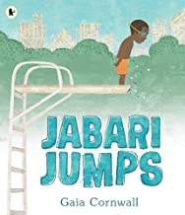](https://www.amazon.co.uk/Jabari-Jumps-Gaia-Cornwall/dp/1406380873/ref=sr_1_1?adgrpid=52956310757&dchild=1&gclid=Cj0KCQjwrIf3BRD1ARIsAMuugNtB-YaNQO-KSzoMZcOBGA9JhgzrmbT2eWnSqvTA2BpKDggXFTp7bpYaApE_EALw_wcB&hvadid=258998211759&hvdev=c&hvlocphy=1006849&hvnetw=g&hvqmt=e&hvrand=173265546264215667&hvtargid=kwd-308236592818&hydadcr=18018_1757046&keywords=jabari+jumps&qid=1591864904&sr=8-1&tag=googhydr-21)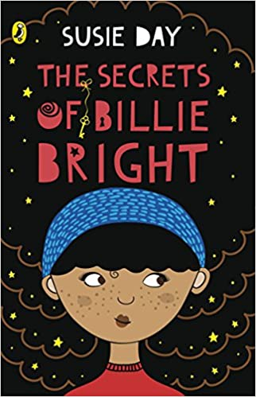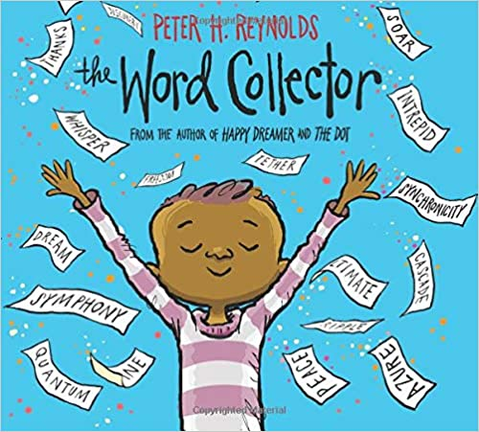

[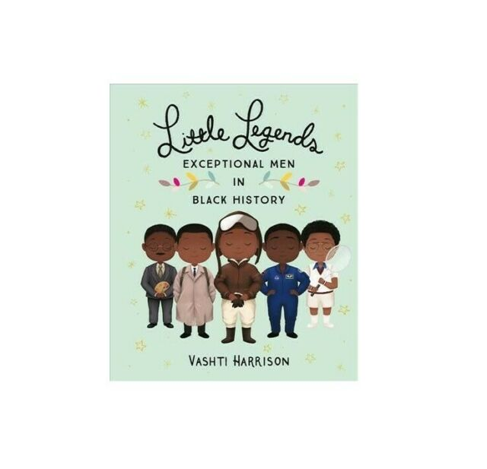](javascript:void(0))[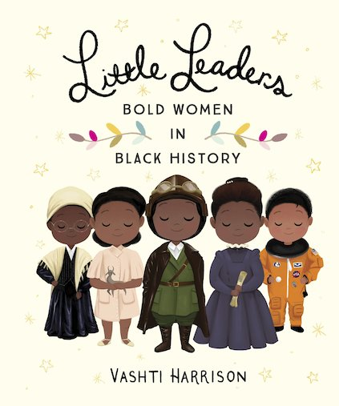](https://d3ddkgxe55ca6c.cloudfront.net/assets/t1534936488/a/62/30/186180-ml-1762802.jpg)[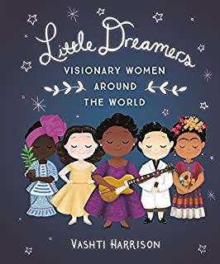](https://www.amazon.com/Little-Dreamers-Visionary-Around-Harrison/dp/0316475173/ref=reads_cwrtbar_2/144-5669292-1513660?_encoding=UTF8&pd_rd_i=0316475173&pd_rd_r=209ffd61-5d3e-4e9a-86b2-6a6ad0cc8619&pd_rd_w=Tn5Jx&pd_rd_wg=GuyLD&pf_rd_p=327bd107-8f81-4cea-8249-0243ca14f16d&pf_rd_r=2CPN0H8S0DBVP1Y1EHQ7&psc=1&refRID=2CPN0H8S0DBVP1Y1EHQ7)

**Legends through time:**

**Not sure where to put these???**

* Inspirational people but I don’t know where to put them – Sudha Chandran (Indian actress, lost her leg in a car actress but still continued with her career)
* Musharaf Asghar – Stammer Moti vational speaker (From Dewsbury)

**PE/Games & Music lessons – Just an idea!?!**

Just an idea but why not as the children are getting changed in PE (so as a starter) each lesson show inspirational athletes/sports people and paralympics too (so like one a lesson). This would expose the children to people from all over the world and also inspire them.

The same could be done in a music lesson. Let children listen to a particular artist at the beginning of the lesson and then educate them in who it is and a bit of history about them.